NSDD Flavor Drill January 2025

Document LA-UR-24-33222. Approved for public release; distribution is unlimited.
Title: NSDD Flavor Drill January 2025
Authors: David J. Mercer and Jennifer Auxier. Thanks also to Andrew Burgoyne, Subrata Chakraborty, William Johnson, Brooke McNeil, John Melin, and Marc Ruch.
Date: 15 Jan 2025
This is the NSDD “Flavor of the Month” drill for January 2025. Difficulty level is 4/10. This exercise is focused on two emerging medical radionuclides and reinforces some technical concepts from previous drills.
Electronic spectra have been provided in CHN and CNF format and will be useful to answer some of these questions. You may also download the spectra at https://sandialabs.github.io/InterSpec/example_problems/flavor_of_the_month/

Question 1: (Optional) Please enter your name or team name and organization.

Question 2: Pb-212 (10.6 hour) is an emerging medical radionuclide used in Targeted Alpha Therapy (TAT). It decays in vivo to Bi-212 (60.6 min) and sometimes to Po-212 (0.3 μs), which are alpha emitters. Pb-212 is usually supplied from a generator with a Ra-224 source (3.7 day) or alternatively Th-228 (1.9 year).
The spectrum Ra-224 Shipment, shown here, was collected 30 cm from a 17-MBq Ra-224 source that was observed at a Customs port of entry. A background spectrum is also available. The detector was a sodium iodide RadSeeker CS with a built-in Na-22 energy calibration source.
Which of the following gamma ray energies are NOT associated with Ra-224 or one of its decay products? Please choose 2 answers.
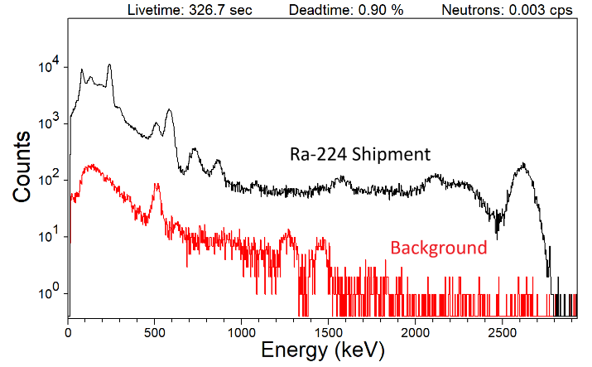
- 238.6 keV
- 241.0 keV
- 277.4 keV
- 300.1 keV
- 510.8 keV
- 511.0 keV
- 583.2 keV
- 727.3 keV
- 860.6 keV
- 911.2 keV

Question 3: The spectrum Ra-224 Unshielded HPGe was collected from an unshielded sample in a laboratory setting.
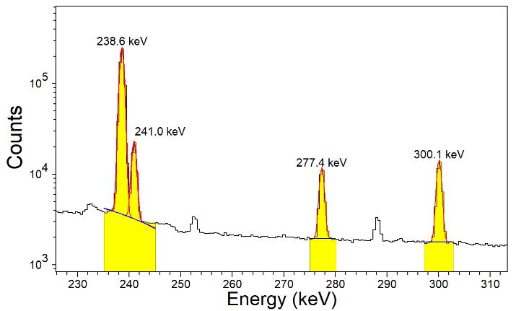
Of the gamma ray energies listed here, which one is emitted from Ra-224 but should NOT be observed from a patient who has received a dose of Pb-212?
- 238.6 keV
- 241.0 keV
- 277.4 keV
- 300.1 keV

Question 4: A radionuclide is under development for single-photon emission computed tomography (SPECT). It has chemical properties identical to Pb-212, so these two radionuclides form a “theranostic” pair. The spectrum SPECT Shipment, shown here, was collected with an NaI RadSeeker. The shipping container includes approximately 3 cm of Pb shielding. A background spectrum is also available.
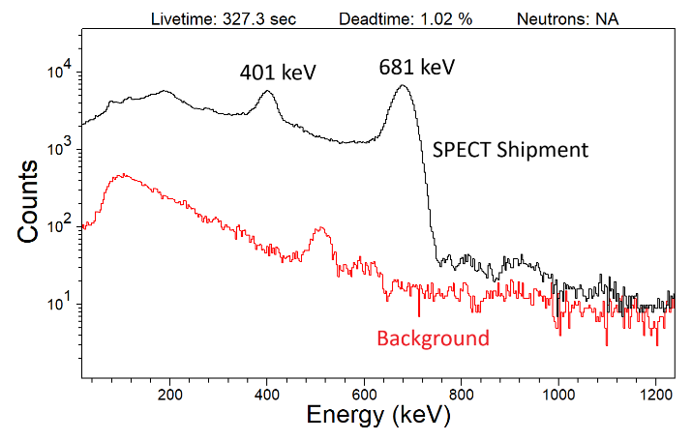
What radionuclide is evident?
- Pb-202
- Pb-203
- Pb-210
- Pb-211
- Pb-214

Question 5: The spectrum Another SPECT Spectrum was collected using an HPGe detector.
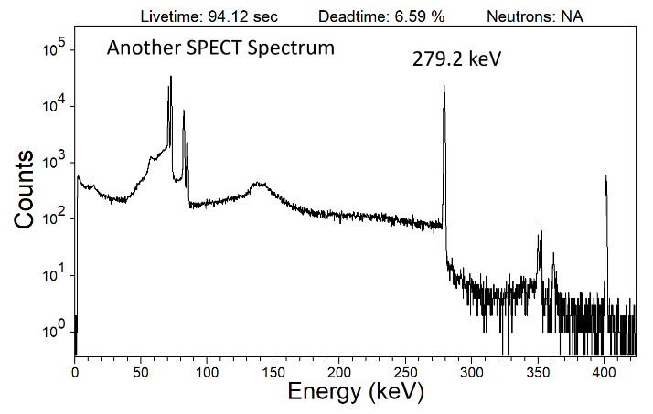
Does the radionuclide appear to be the same one that you identified in Question 4?

Question 6: Also considering the spectrum Another SPECT Spectrum,
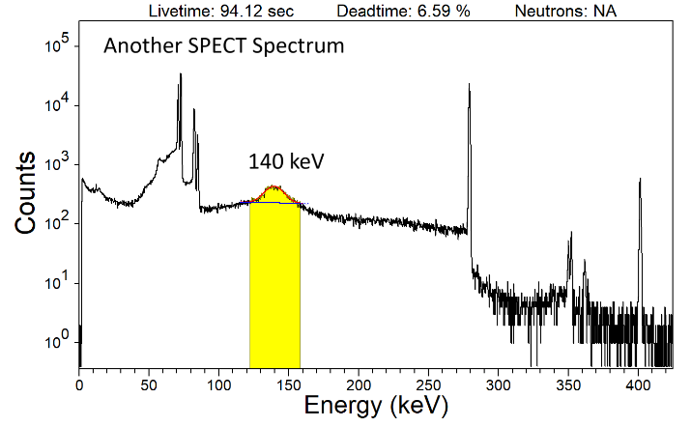
which phenomena contribute counts to the broad artifact appearing near 140 keV?
You may choose multiple answers.
- Backscatter peak from the 279-keV peak
- Compton edge from the 279-keV peak
- Contamination from a Tc-99m impurity
- Single escape (SE) from the 681-keV peak
- Sum peaks from the Tl X-rays near 70 keV

Question 7: Also considering the spectrum Another SPECT Spectrum,
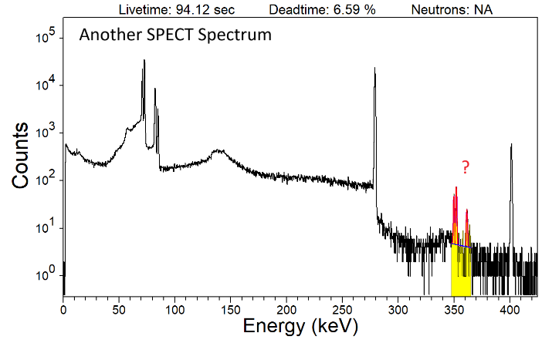
which phenomenon causes the group of peaks visible near 350 keV?
- Germanium X-ray escape from the 401-keV gamma rays
- Sum peaks combining Tl X-rays and 279-keV gamma rays
- Weak gamma rays from the primary radionuclide identified in Question 4
- Gamma rays from a Pb-214 impurity

